# Computer Practical ‘Deterministic models of infectious disease dynamics – compartmental models’. Answer key

1. Deterministic SIR model.

(a) You can look at the plot for the answers, but get a more precise number by looking at the “output” vector [type ode.out, then enter]. The Y-curve drops below 1 at approx t = 88. The peak Y is just above 9000. The number of susceptibles at the end is about 1785.

Changing the beta and gamma separately will change R0 and thus the final size and peak prevalence. Change both such that R0 stays the same (e.g. multiplying both parameters by 2) will speed up the epidemic, but not the peak prevalence and final size will not change.

(b) Start is at bottom right, end at bottom left. The peak is halfway, where Y is

maximal. Number of susceptibles is 1785 (as in (a)).

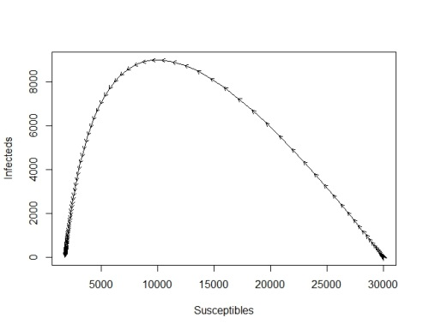

end

peak

start

(c) If *R*0 is smaller, the final size and peak prevalence is lower. If the infectious period is longer (and *R*0 the same), the final size and peak prevalence do not change, but the outbreak takes longer.

(d) The final size is practically 0. This is always the case if *R*0 *X/N* < 1, ie if the proportion of susceptibles is sufficiently low (herd immunity).

(e) The Y-curve drops below 1 at approx t =116. The peak Y is just above 6330. The number of susceptibles at the end is about 1785.

(f) As in (c). The latent period results in longer outbreaks, and lower peak prevalences, but it does not affect the final size.

2. Birth/immigration and death/emigration (deterministic)

(a) You see oscillations, and ultimately a steady state is reached. If you plot Y against X , you see the oscillations as a curl towards a centre, which is the endemic steady state.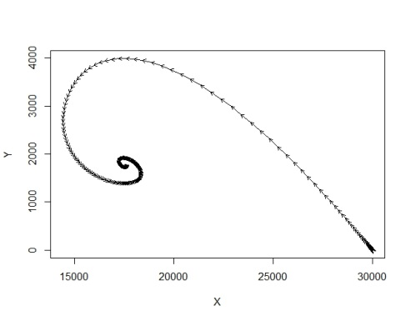

Endemic steady state

2nd peak

1st peak

start

(b) *R*0 = */*(** + **). The steady state for *X* is equal to *N/R*0. If ** is much smaller than **, oscillations are strong, whereas if ** is of the same order of magnitude, there are not many oscillations.